**Cam’s Space Defender**

**Game Design Document**

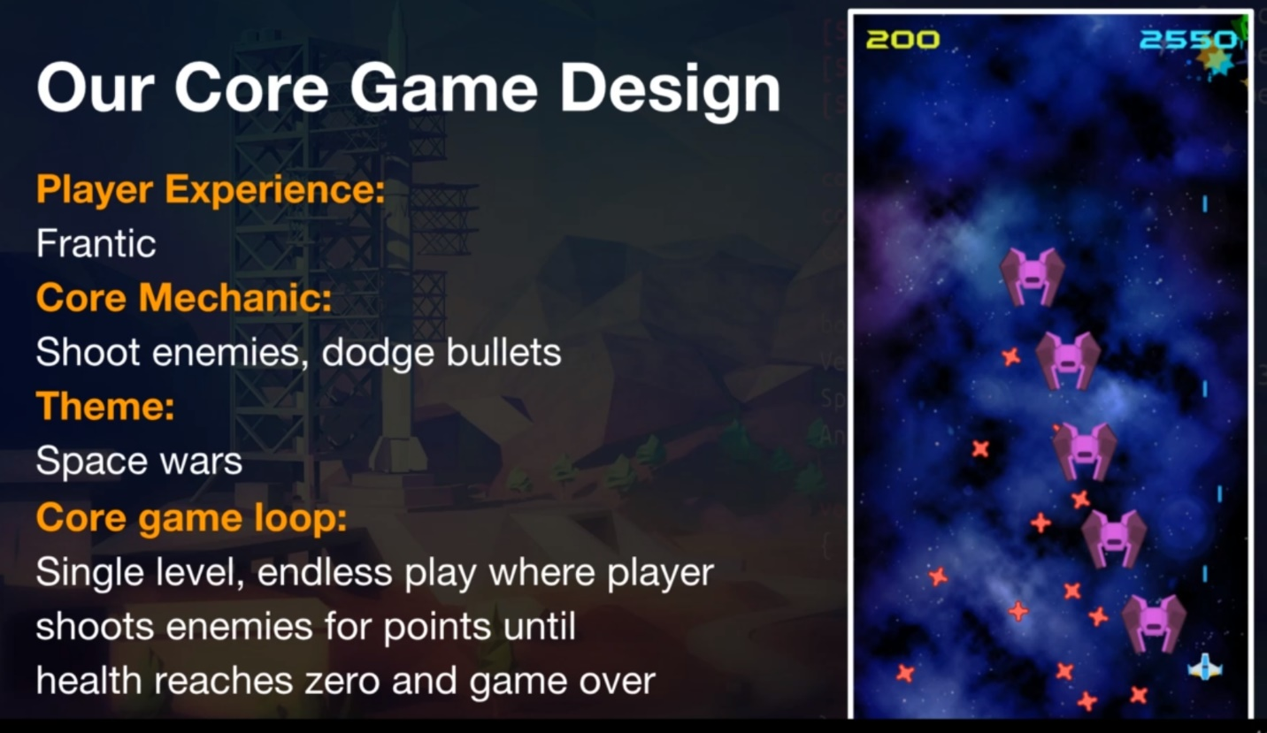

**Who is the player?**

The casual game player

**What is the player experience?**

Fast action and frantic

**What is the game theme?**

War in Space

**What is the core mechanic?**

Shoot Enemies and dodge bullets

**What is the goal (core game loop)?**

Single level, endless play where player shots enemies for points until health is zero and the game is over.

**Game Flow**

**TODO - Not this game’s game flow**

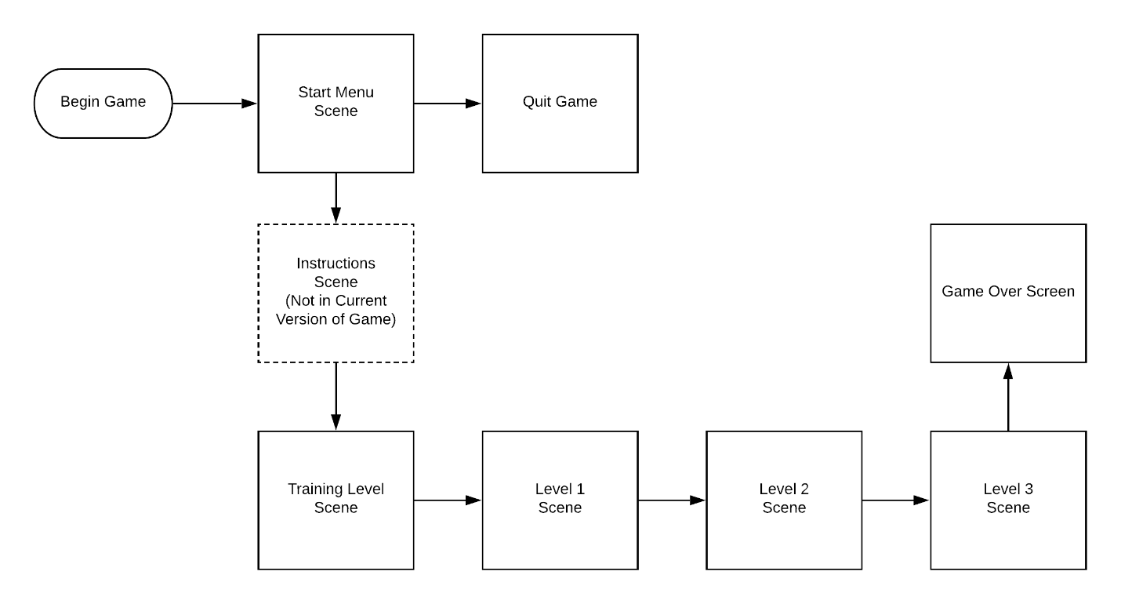

**Game Feature Areas**

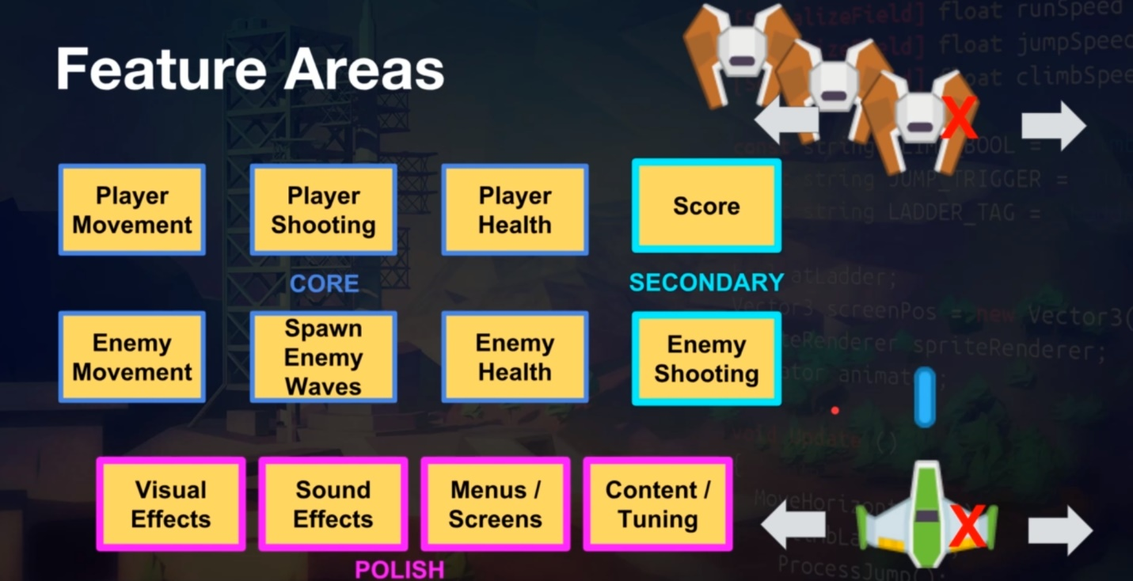

**Scenes**

**Start Menu Scene**

**Training Level Scene**

**Instructions Scene (Not in Game)**

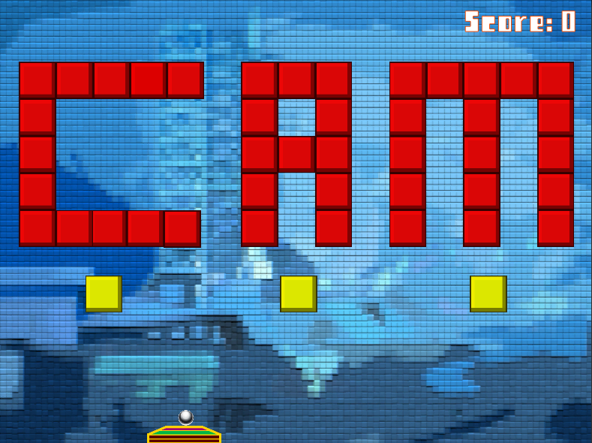

**Level 1 Scene**

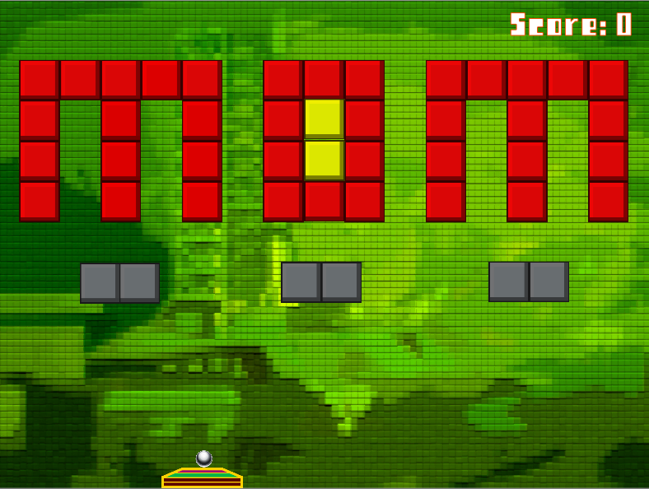

**Level 2 Scene**

**Level 3 Scene**

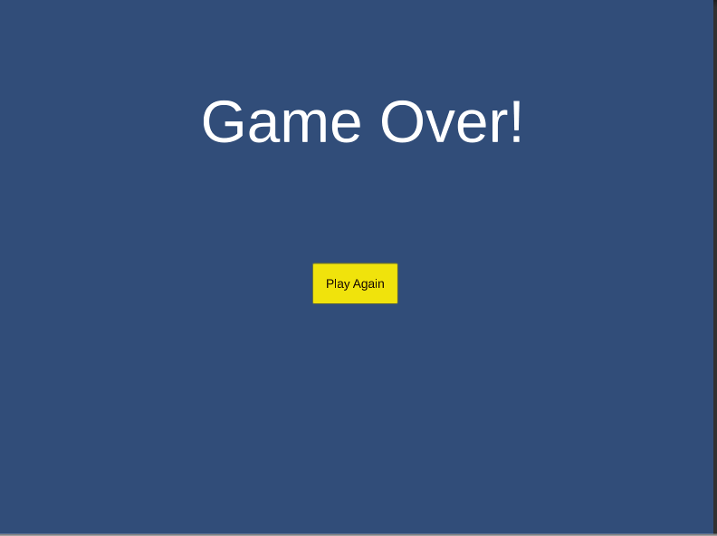

**Game Over Screen**

**To Do List For Next Version**

1. Create and display an instructions screen
2. Allow player to select difficulty level (Ie. easy, medium, hard). Adjust ball velocity based on player’s input.
3. Create and display a persistent High Score screen that shows ten player’s initials and high scores.
4. Adjust score based on type of blocks
   1. 1 Hit Block = 10 points
   2. 2 Hit Block = 20 points
   3. 3 Hit Block = 30 points
5. Configure game for multiple screen resolutions

**References:**

SaveMyGame.com Link